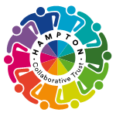

Curriculum Overview Yearly Plan - Year 2
 | Term 1 | Term 2 | Term 3 | Term 4 | Term 5 | Term 6
Reading  Core Texts  Supporting Texts | 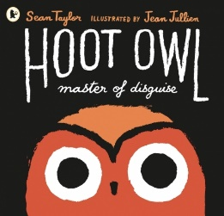  Hoot Owl – Master of Disguise  by Sean Taylor  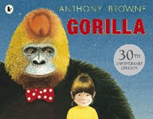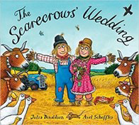  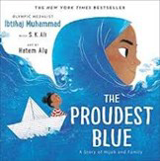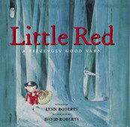  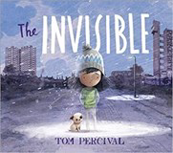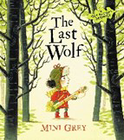 | 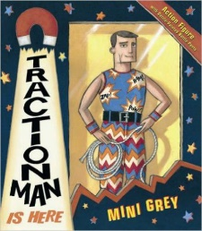  Traction Man  By Mini Grey  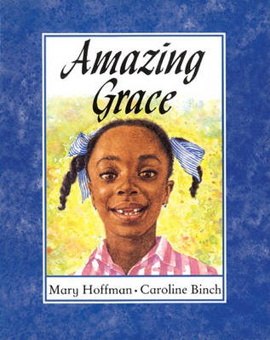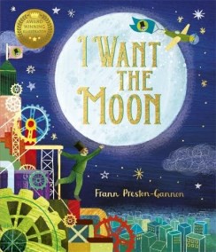  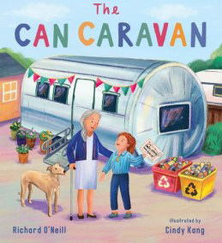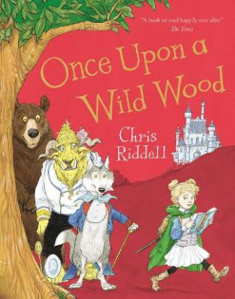  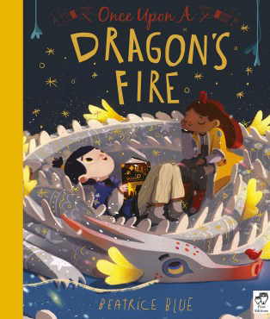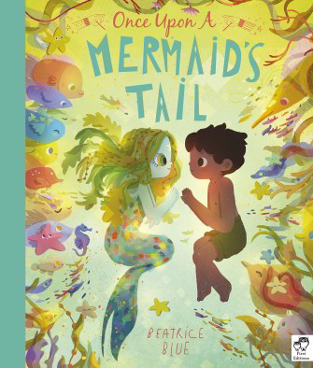 | 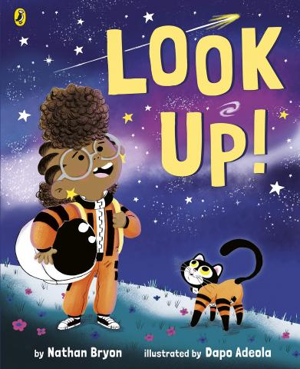  Look Up!  By Nathan Bryon  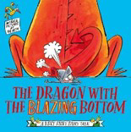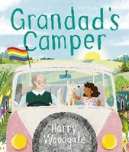  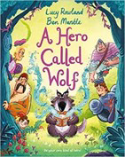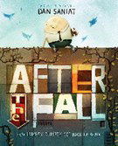  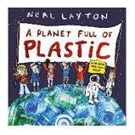 | 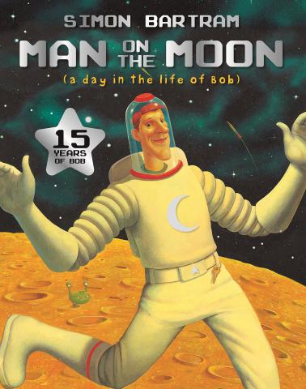  Man on the Moon  By Simon Bartram  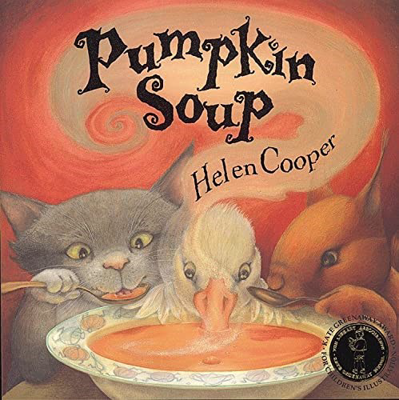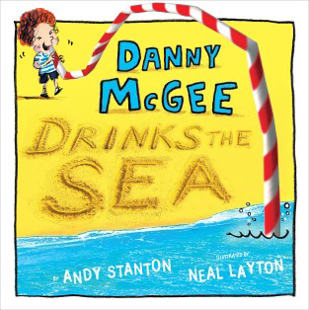  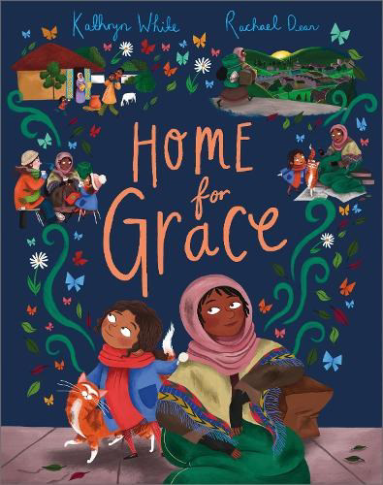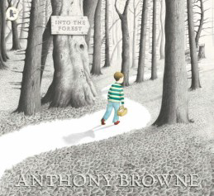  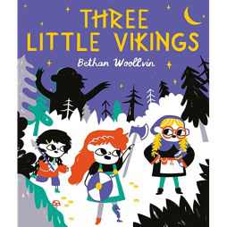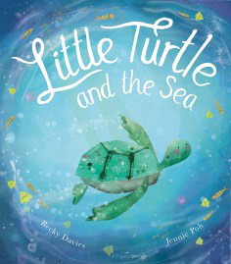 | 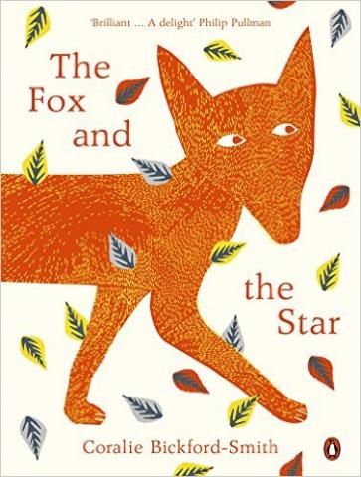  The Fox and the Star  By Coralie Bickford-Smith  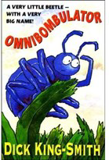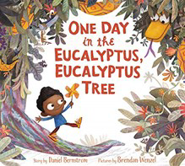  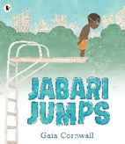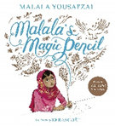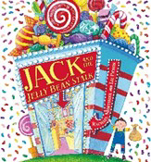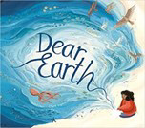 | 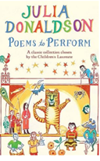  Poems to Perform  By Julia Donaldson  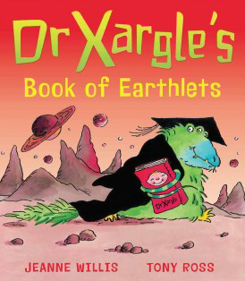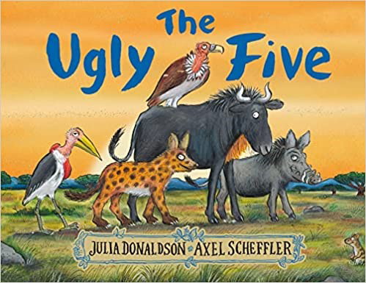  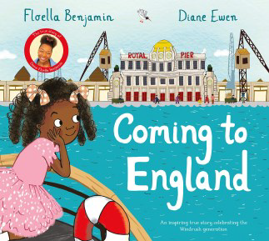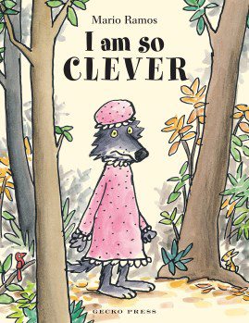  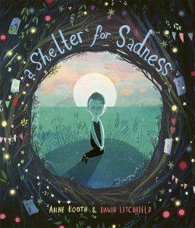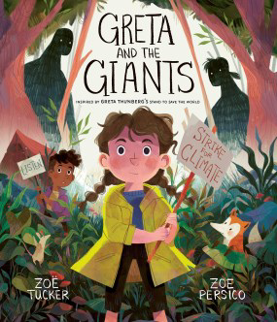
Writing | Genres:  Non-chronological report  Narrative writing | Genres:  Character Profile  Adventure Story  Descriptive Poetry | Genres:  Persuasive leaflet  Biography | Genres:  Letter writing  Recount | Genres:  Ode  Information text  Narrative | Genres:  Performance poetry  Instructions
Maths  Following White Rose | Number: Place Value  Number: Addition and Subtraction  Geometry: Shape |  | Measurement: Money  Number: Multiplication and Division  Measurement: Length and Height  Measurement: Mass, capacity and temperature |  | Number: Fractions  Measurement: Time  Statistics  Geometry: Position and Direction  Consolidation
History  Following Kapow | Identifying similarities and differences – Changes within Living Memory  How was school different in the past?  -Correctly order and date four photographs on a timeline and add some dates.  -Ask one question about schools in the past.  -Make one comparison between schools in the past and present.  -Use sources to research and develop an understanding of what schools were like 100 years ago.  -Identify three features of a classroom now and a classroom 100 years ago, identifying some similarities and differences.  -Recognise two similarities and two differences between schools now and schools in the past.  -State whether they would have preferred to go to school in the past or not and explain why. |  | Significant Historical Events/Events beyond living memory  -How did we learn to fly?  -Identify important events surrounding the history of flight.  -Explain how a significant event has changed the lives of others.  -Ask questions about people and events in the past.  -Use primary sources to find out about people and events in the past.  -Correctly order five events on a timeline |  | The lives of significant individuals  What is a Monarch?  -Recall that a monarch is a king or queen.  -Explain that recent monarchs in the UK do not have the power to make decisions alone.  -Identify some of the monarch’s roles.  -Explain that a king or queen is crowned in a special ceremony called a coronation.  -Name some of the main steps in the coronation ceremony.  -Explain the use of special objects in the coronation.  -Use sources to explain how William the Conqueror became King of England.  -Know that monarchs in the past had all the power to make decisions.  -Explain how William the Conqueror kept order and conquered England.  -Identify the two different types of castle built by the Normans.  -Compare the similarities and differences between Norman castles.  -Identify features of Norman castles.  -Explain how castles have changed over time.  -Recognise that we still have castles today.  -Sequence castles on a timeline.  -Describe characteristics of the monarchy in the past.  -Identify that the monarchy has changed over time.  -Make comparisons between past and present monarchy.
Geography  Following Kapow | Would you prefer to live in a hot or cold place?  -Name and locate the seven continents on a world map.  -Locate the North and the South Poles on a world map.  -Locate the Equator on a world map.  -Describe some similarities and differences between the UK and Kenya.  -Investigate the weather, writing about it using key vocabulary and explaining whether they live in a hot or cold place.  -Recognise the features of hot and cold places.  -Locate some countries with hot or cold climates on a world map. |  | Why is our world wonderful?  -Identify and locate characteristics of the UK on a map.  -Identify human and physical features.  -Locate human and physical features on a world map.  -Explain the difference between oceans and seas.  -Name and locate the five oceans on a world map.  -Use an aerial photograph to draw a simple sketch map.  -Collect data by sketching findings on a map and completing a tally chart.  -Present their findings in a bar chart. |  | What is it like to live by a coast?  -Name and locate the seas and oceans surrounding the UK in an atlas.  -Label these on a map of the UK.  -Describe the location of the seas and oceans surrounding the UK using compass points.  -Define what the coast is.  Locate coasts in the UK.  -Name some of the physical features of coasts.  -Explain the location of UK coasts using the four compass directions.  -Name features of coasts and label these on a photograph.  -Identify human features in a coastal town.  -Describe how people use the coast.  -Follow a prepared route on a map.  -Identify human features on the local coast.  -Record data using a tally chart.  -Represent data in a pictogram.  -Describe how the local coast has been used.
Design Technology  Following Kapow | Mechanics – Fairground wheel  -Design and label a wheel.  -Consider the designs of others and make comments about their practicality or appeal.  -Consider the materials, shape, construction and mechanisms of their wheel.  -Label their designs.  -Build a stable structure with a rotating wheel.  -Test and adapt their designs as necessary.  -Follow a design plan to make a completed model of the wheel.  Mechanics – Making a Moving Monster  -Identify the correct terms for levers, linkages and pivots.  -Analyse popular toys with the correct terminology.  -Create functional linkages that produce the desired input and output motions.  -Design monsters suitable for children, which satisfy most of the design criteria.  -Evaluate their two designs against the design criteria, using this information and the feedback of their peers to choose their best design.  -Select and assemble materials to create their planned monster features.  -Assemble the monster to their linkages without affecting their functionality. |  | Cooking and Nutrition – Balanced Diet  -Name the main food groups and identify foods that belong to each group.  -Describe the taste, feel and smell of a given food.  -Think of three different wrap ideas, considering flavour combinations.  -Construct a wrap that meets the design brief and their plan. |  | Textiles – Puppets  -Join fabrics together using pins, staples or glue.  -Design a puppet and use a template.  -Join their two puppets’ faces together as one.  -Decorate a puppet to match their design.  Textiles – Pouches  -Sew a running stitch with regular-sized stitches and understand that both ends must be knotted.  -Prepare and cut fabric to make a pouch from a template.  -Use a running stitch to join the two pieces of fabric together.  -Decorate their pouch using the materials provided.
Art  Following Access Art | Drawing – explore and draw.  Pathway for Years 1 & 2  Disciplines:  Drawing, Sketchbooks, Collage  Key Concepts:  -That artists explore the world, seeing things around them in new ways, and bring things back to their studios to help them make art.  -That we can go into our own environments, even when they are very familiar to us, and learn to see with fresh eyes and curiosity.  -That we can use the things we find to draw from, using close observational looking.  -That we can explore and use art materials, be inventive with how we use them, taking creative risks and enjoying accidents as well as planned successes.  -We can use the shape of the page, and the way we arrange elements on the page, to create compositions which we like.  Themes:  Natural Forms, Seasonal Changes, Patterns, Symmetry.  Medium:  Graphite, Handwriting Pen, Watercolour/Brusho, Wax Resist.  Artists:  Rosie James, Alice Fox. |  | Printing – exploring the world through monoprint  Pathway for Years 1 & 2  Disciplines:  Printmaking (Mono Print), Drawing, Collage  Key Concepts:  -When we make mono prints we use mark making to create one off prints.  -When we make mono prints we create an impression of a drawing.  -That we can generate playful narratives and inventions through drawing.  -That we understand that using a range of marks will generate different effects when creating mono prints.  -That we can create creative responses to different stimuli and make the work our own.  Themes:  Natural and Manmade Forms, Invention, Narrative  Medium:  Graphite pencils, Oil Pastels, Carbon Paper  Artists:  Xgaoc’o X’are, Leonardo Di Vinci. |  | Making – stick transformation  Pathway for Years 1 & 2  Disciplines:  Making, Drawing, Sketchbooks  Key Concepts:  -That artists use their creativity to look at the world in new ways and use their hands to transform materials into new things.  -That making art can be playful and fun. That we can create things for other people to enjoy/use.  -That we can use our imagination to help us shape the world.  Medium:  Twigs, Construction Materials, Paper, Wool, Drawing Materials  Artists:  Chris Kenny
Music  Following Charanga | Hands, Feet, Heart  South African Music  Style: South African styles  Topic and cross-curricular links: South African music and Freedom Songs. Nelson Mandela as a famous and inﬂuential person in our lifetimes. Historical context of musical styles.  Links to other units: Fishing Song - Britten - KS2/ages 7-11 (see Freestyle) | Ho Ho Ho!  Christmas Music  Style: Christmas, Big Band, Motown, Elvis, Freedom Songs  Topic and cross-curricular links: Christmas. Literacy - Christmas vocabulary. Historical context of musical styles.  Links to other units: Christmas units | I Wanna Play in a Band  Rock Music  Style: Rock  Topic and cross-curricular links: Teamwork, working together. The Beatles. Historical context of musical styles.  Links to other units:  Livin' On A Prayer - KS2/ages 7-11 (Scheme Year 5)  Don't Stop Believin' - KS2/ages 7-11 (see Freestyle) | Zootime  Reggae Music  Style: Reggae  Topic and cross-curricular links: Animals, poetry and the historical context of musical styles.  Links to other units:  Three Little Birds - KS2/ages 7-11 (Scheme Year 3) | Friendship Song  Mixed Styles  Coming Soon… | Reflect, Rewind, Replay  Western Classical Music  Style: Western Classical Music and your choice from Year 2  Topic and cross-curricular links: Think about the history of music in context, listen to some Western Classical music and place the music from the units you have worked through, in their correct time and space. Consolidate the foundations of the language of music.  Links to other units: All Year 2 units
Science  Kapow | Living Things: Habitats  Children will be able to:  -Ask questions to further their knowledge.  -Recall some life processes, giving examples of how they apply to plants and animals.  -Classify objects into alive, never been alive and was once alive, giving reasons for their choices.  -Match different plants and animals to their habitats.  -Give examples of how animals use their habitat for food and shelter.  -Recall that plants produce their own food for energy.  -Name living things that are producers and place a producer at the beginning of a food chain.  -Use arrows to show the order in a food chain. | Living Things: Microhabitats.  Children will be able to:  -Identify and name a variety of plants and animals.  -Recall that minibeasts live in microhabitats.  -Describe microhabitats and their conditions.  -Describe how microhabitats provide for the basic needs of animals and plants.  -Describe the job role of a botanist.  Working scientifically:  -Group minibeasts and create simple classification keys.  -Ask questions and recognise that they can be answered in different ways.  -Gather and record data and use it to answer questions.  -Plan what observations to make in an experiment.  -Order the steps of a method.  -Describe the appearance of flowering plants.  -Use an identification chart to name flowering plants. | Materials:  Uses of everyday materials  Children will be able to:  -Name objects with the same use that are made from different materials.  -Name materials that are used to make objects with different uses.  -Recognise that stretching, twisting, bending and squashing can cause some solid objects to change shape.  -Name properties that make materials suitable for their use.  Working scientifically:  -Measure using non-standard units.  -Recording results in a table.  -Use data to answer a simple question.  -Record results in a block graph. | Animals Lifecycles and Health  -Children will be able to:  -Identify stages in the life cycles of different animals, including humans.  -Describe the basic survival needs of animals.  -Explain how to take care of personal hygiene.  -Describe some positive effects of exercise.  -Identify foods in different food groups.  Working scientifically:  -Measure using simple equipment.  -Record results in a table.  -Use data to answer a simple question.  -Research using secondary sources. | Plants  Children will be able to:  -Recall that seeds have all the necessary parts inside for plants to grow.  -Recall that seeds need water and warmth to germinate.  -Recognise that light is required for healthy plant growth.  -Sequence the stages of a plant’s life cycle.  -Recognise the importance of healthy plant growth.  -Describe the influences humans have on plants in the environment.  Working scientifically:  -Set up comparative tests.  -Plan observations and measurements.  -Use rulers to measure and record stem height.  -Record plant growth data in a table.  -Compare plant growth in different test conditions.  -Use a magnifying glass to observe and compare plants.  -Draw diagrams to represent stages of a plant’s life cycle. | Making Connections  Children will be able to:  - Explain the terms reduce, reuse and recycle.  -Describe how paper is made.  -Select suitable materials for a plant pot.  -Describe good growth conditions for seeds.  -Make a plant pot from eco-friendly materials.  -Identify non-living materials to decorate a plant pot.  Working scientifically:  -Use an online source to find answers to questions.  -Identify and classify different types of material.  -Classify natural and human-made materials.  -Carry out tests to assess the properties of different materials.  -Use observations to answer questions.  -Draw conclusions about the suitability of materials.
Computing  Following  MrPict  E-Safety  -recognise common uses of information technology beyond school.  -use technology safely and respectfully, keeping personal information private; identify where to go for help and support when they have concerns about material on the internet or other online technologies.  (See separate document for e-safety skills) | Presentations  Interactive Image  Using Thinglink  Children will:  -know how to add voice labels to an image  Presentations  Speech bubble Pictures  Using Balloon Stickles+  Children will:  -know how to add speech bubbles to an image to show what a character is thinking. | Presentations  Animal Catchphrase Quiz  Using Keynote  Children will:  -know how to add voice labels to an image.  -know how to import images to a project from the web and camera roll.  -know how to use some build in animations in presentation software.  Photo and Digital Art  Photoshopping  Using Pic Collage  Children will:  -know how to add voice labels to an image.  Photo and Digital Art  Robot Avatars  Using Keynote  Children will:  -know how to select and use tools to create digital imagery.  -know how to rotate, resize, and change the colour of shapes.  -know how to subtract or exclude shapes.  -know how to edit a photo (crop, filters, mark up etc). | Data Handling  Venn Diagrams  Using Pic Collage or Seesaw  Children will:  -know how to sort digital objects into a range of charts such as Venn diagrams, Carroll diagrams and other bar charts using different apps and software.  -know how to orally record themselves explaining what the data is showing.  -know how to use the space bar only once between words and use touch to navigate to words letter to edit.  -know how to copy and paste images and text.  -know how to use caps lock for capital letters.  -know how to add images alongside text in a word-processed document.  Animation  Stop Motion Animation  Using I Can Animate  Children will:  -know how to create multiple animations of an image and edit them together.  -know how to create a simple stop motion animation.  -be able to explain how an animation/flip book works. | AR and VR  Storytelling with AR  Using ARMakr  Children will:  -be able to choose and create different types of animations to best explain their learning.  -know how to create videos using a range of media – green screen, animations, film and image.  -know how to bring objects into their surroundings using Augmented Reality.  Video Creation  Masking Storytime  Using Doink Greenscreen  Children will:  -know how to record a film using the camera app.  -know how to select images and record a voiceover.  -be able to highlight and zoom into their images as they record.  -know how to use tools and add effects to a video.  -know how to being to use green screen techniques and masking with support. | Artificial Intelligence  AI Advantages Video  Shadow Puppets Edu or Adobe Spark  Children will:  -be able to explain some advantages and disadvantages of using simple AI technology.  -know how to use tools to add effects to a video.  -know how to add a voice recording to a storyboard.  Programming  Knock Knock Joke  Scratch 3.0  Children will:  -know that programs follow precise instruction.  -know how to create programs using different digital devices E.g. Bee Bot or Scratch Jrn on a tablet.  -know how to debug programs of increasing complexity.  -know how to use logical reasoning to predict the outcome of simple programs. | Programming  Robot Helper  Children will:  -know that programs follow precise instruction.  -know how to create programs using different digital devices E.g. Bee Bot or Scratch Junior on a tablet.  -know how to debug programs of increasing complexity.  -know how to use logical reasoning to predict the outcome of simple programs.  Programming  Algorithms  Bee Bot App  Children will:  -know that programs follow precise instruction.  - know how to create programs using different digital devices E.g. Bee Bot or Scratch Jrn on a tablet.  -know how to debug programs of increasing complexity.  -know how to use logical reasoning to predict the outcome of simple programs.
PSHE, SMSC, SRE, Wellbeing  Following Jigsaw | Being me in my World  Children will:  - identify some of my hopes and fears for this year.  - understand the rights and responsibilities for being a member of their class and  School.  - listen to other people and contribute their own ideas about rewards and consequences.  - understand how following the Learning Charter will help them and others learn.  - recognise  the choices they make and understand the  consequences. | Dreams and Goals  Children will:  -choose a realistic goal and think about how to achieve it.  - carry on trying (persevering) even when they find tasks difficult.  - recognise who I work well with and who it is more difficult for me to work with.  -work well in a group to create an end product.  - explain some of the ways they worked well in their group to create the end product.  - know how to share success with other people. | Healthy Me  Children will:  - know what they need to keep my body healthy.  - show or tell you what relaxed means and they know some things that make me feel relaxed and some that make them feel stressed.  - understand how medicines work in their body and how important it is to use them safely.  - sort foods into the correct food groups and know which foods their body needs every day to keep them healthy.  - make some healthy snacks and explain why they are good for their body.  - understand which foods to eat to give their body energy. | Celebrating Difference  Children will:  - start to understand that sometimes people make assumptions about boys and girls (stereotypes).  - understand that bullying is sometimes about difference.  - recognise what is right and wrong and know how to look after themselves.  - understand that it is OK to be different from other people and to be friends with them.  - tell you some ways they are different from their friends. | Relationships  Children will:  - identify the different members of their family, understand their relationship with each of them and know why it is important to share and cooperate.  - understand that there are lots of forms of physical contact within a family and that some of this is acceptable and some is not.  - identify some of the things that cause conflict with their friends.  - understand that sometimes it is good to keep a secret and sometimes it is not good to keep a secret.  - recognise and appreciate people who can help them in their family, their school and their community.  - express their appreciation for the people in their special relationships. | Changing Me  Children will:  - recognise cycles of life in nature.  - tell you about the natural process of growing from young to old and understand that this is not in their control.  - recognise how their body has changed since they were a baby and where they are on the continuum from young to old.  - recognise the physical differences between boys and girls, use the correct names for parts of the body (penis, testicles, vulva, vagina, anus) and appreciate that some parts of their body are private.  - understand there are different types of touch and can tell you which ones they like and don’t like.  - identify what they are looking forward to when they move to my next class.
RE  Following Kapow  Religion and Worldviews | Why do we need to give thanks?  -Identify reasons people may feel thankful and how this is expressed.  Explain how some people celebrate harvest time.  -Identify the meaning behind some harvest celebrations and practices.  -Talk about what Hindu and Christian followers might learn from stories about gratitude.  -Explain how some Hindus and Christians show their gratitude to God.  -Explain how Hindu worship may reflect a person’s beliefs about gratitude to God.  -Recognise how worship through songs can be used to express thanks to God.  -Express ideas about gratitude using music. | What do candles mean to people?  -Share examples of where they have seen and experienced candles.  -Identify three practices associated with Diwali.  -Understand that some Hindu people use diyas as symbolism.  -Understand the meaning of Advent to some Christian followers.  -Identify what is important to some Jewish people at Hanukkah.  -Explain what a hanukiah symbolises.  -Understand their own positionality on what candles mean to them.  -Provide some examples of what candles mean to some people. | How do we know some people have a special connection to God?  -Recognise parts of Jesus’ birth story that tell us some people believe Jesus is special.  -Understand that religious stories can help us learn about religious beliefs.  -Identify some parts of the story that tell some people that Guru Nanak was special as a baby.  -Identify miracles in the stories that tell some people that some children are special.  -Make comparisons to other stories.  -Describe why Krishna might be seen as special by some people.  -Identify parts of the story that tell us that Muhammad is special to some people.  -Identify a miracle believed to have been performed by Jesus as an adult and the significance in religious stories. | What is a prophet?  -Identify how some prophets’ feelings changed and explain the people’s reactions to new prophets.  -Understand the promises God made to some individuals, including promises shared across the Christian and Jewish worldviews.  -Describe the story of the Night Journey and identify common prophets in the Muslim, Christian and Jewish worldviews.  -Explain Jesus’ varied role in the Jewish, Christian and Muslim worldviews, identifying similarities and differences in these perspectives.  -Describe how a guru might be similar to a prophet.  -Explain what makes some prophets important to the people in the worldviews they explore. | How do some people talk to God?  -Describe what prayer means.  Identify some reasons why people might pray.  -Explain how some people use their bodies during prayer.  -Identify some similarities and differences between the ways in which people pray.  -Understand why special objects and items of clothing are important to some people when they pray.  -Draw connections between prayer practices within the Hindu, Muslim and Jewish worldviews. | Where do some people talk to God?  -To identify some features of mosques and their importance to some Muslims.  -To explain how the features of an Orthodox Christian church might help some people pray.  -To make connections between beliefs about the Trinity and Christian places of worship.  -To identify some features of a synagogue and discuss their importance.  -To recognise that community and equality are important values to many Sikh people.  -To explain what the similarities and differences between places of worship can tell us about some people’s beliefs.
PE  Following Greenacre PE | Year 1 focused depending on cohort’s targets.  Tri Golf  1 To familiarise pupils with the golf course: holes, tees, water and the sand bunker.  To learn underarm throwing and how this relates to tri golf.  2 To learn how to play golf without equipment.  3 To learn the basic putting technique. The focus being on power and body positioning.  4 To learn how to use a putter in a game situation using a score card.  5 To develop the fundamental skills of chipping a golf ball.  6 To be able to use their knowledge and skills within a full round of golf. | Tag Rugby  1 Pupils learn how to dodge and weave an object using speed and direction.  Pupils learn what agility is and why we use it in Tag Rugby.  2 Pupils learn how to become familiar with a rugby ball. How to hold it and how to catch it with two hands.  3 Pupils learn how to use the correct technique to throw the rugby ball in a straight line.  They focus on aiming at a target.  4 Pupils learn how to mark/shadow another person and why we do this. They also have an introduction to tagging.  5 Pupils learn how to pass and move towards a goal area. Combining passing and running skills.  6 Pupils learn how to score in rugby by placing the ball down in target areas.  They learn how to work as a team communicating ideas and rules.  Dance  1 Pupils have an introduction to learning basic actions and pupils learn how to improvise and copy basic movement patterns in  partners.  2 Pupils learn how to respond to a variety of stimuli e.g. words, poetry, pictures, sounds, videos, and objects. They explore different  ways to use movement to reflect the stimulus. They practice their dance in groups trying to keep in unison.  3  Pupils learn different stage directions used in dances.  They attempt to use these directions in the dance that has been created up to now.  4 Pupils learn how to express moods and feelings in dance to tell a story or convey an idea.  Pupils will create scenarios of their own to expand the storyline and expression in their dance.  5 Pupils learn how to create a clear, middle and end to their routines by using stillness. Pupils work in pairs to communicate ideas.  6 Competition week: Pupils learn basic performance skills, and use these in their final dance, to gain points from the judge.  Prizes/House Points can be awarded. | Football  1 Familiarisation of the Ball: Pupils begin to use their feet to move around an area and learn the basic rules of football.  2 Dribbling: Pupils learn the correct technique of how to dribble a ball.  3 Short Passing: Pupils learn how to pass a ball over a short distance using the inside of their foot.  4 Long Passing: Pupils learn how much power is needed to pass a ball over a long distance and why a long pass is used.  5 Shooting: Pupils will learn how to strike a ball and also the difference between passing and shooting.  6 Game Situations: Pupils link all of the skills learnt over the past 5 weeks and put them into a game situation.  Multi skills | Cricket  1 To learn and understand basic fielding skills using the one handed underarm throwing technique.  2 To learn the basic underarm bowling action and to introduce the role of a wicket keeper.  3 To learn basic fielding skills catching a low ball.  4 Fundamental fielding skills, running a batter/runner out by returning the ball to the Wicket Keeper.  5 Learning the basic concepts of playing a Kwik Cricket game.  6 Developing the basic concepts of playing a Kwik Cricket game.  Gymnastics  1 To learn how to use their hands and feet to travel around an area.  2 To learn how to create a variety of different shapes with their body.  3 To learn how to jump effectively and safely and apply this in a routine.  4 To learn how to perform a variety of different balances.  5 To learn how to use small apparatus safely within a routine.  6 To learn how to develop a gymnastics sequence, using shapes, balancing, jumping and travel. | Infant Agility  1 To learn the correct running technique for short distance running.  2 Learn the correct technique to perform the chest push pass.  3 Learn and understand different ways to balance.  4 To learn how to jump and land correctly.  5 To develop hand - eye coordination.  6 Continue to develop hand – eye coordination.  Tennis  1 Students learn to understand the similarities between throwing and rolling the ball underarm to the forehand shot.  2 Students take part in exercises which continue to develop their ability to play a forehand shot in Tennis.  3 The teacher introduces the volley shot. The students understand what is meant by the term ‘Volley’.  4 The pupils take part in activities to improve their ability to volley the ball. The teacher ensures their stance is correct  and when they make contact with the ball the racket is facing up.  5 The students are introduced to how they start a rally in Tennis using a Serve. Students practice serving to targets to  increase their ability the perform the serve whilst thinking about accuracy.  6 Students take part in a number of activities which enable them to showcase all the skills they have learnt over the  course of the term. | Infant Agility  1 To learn the correct running technique for short distance running.  2 Learn the correct technique to perform the chest push pass.  3 Learn and understand different ways to balance.  4 To learn how to jump and land correctly.  5 To develop hand - eye coordination.  6 Continue to develop hand – eye coordination.  Rounders  1 Pupils learn how to perform a two handed and one handed catch with the correct technique for striking  and fielding games.  2 Pupils learn to link both throwing and catching as an introduction to a bowling technique.  Focus is on pupils aiming and accuracy skills.  3 Pupils learn to make a striking action and to make contact with a moving ball.  4 Pupils learn running skills and experiment with the speed and acceleration within fun modified games.  5 Pupils learn to chase the ball and how to pick the ball up whilst on the move.  Combining skills together to gain good fielding knowledge.  6 Pupils learn basic rules and positions and play enjoyable modified games with a competitive element to encourage the  use of their skills in a game situation.
School Values | Week 1/2: Aspiration  Week 3/4: Kindness  Week 5/6: Reflection | Week 1/2: Resilience  Week 3/4: Kindness  Week 5/6: Reflection | Week 1/2: Aspiration  Week 3/4: Kindness  Week 5/6: Reflection | Week 1/2: Kindness  Week 3/4: Reflection  Week 5/6: Resilience | Week 1/2: Aspiration  Week 3/4: Kindness  Week 5/6: Reflection | Week 1/2: Kindness Week 3/4: Reflection  Week 5/6: Aspiration
Visitors/Trips

Whole School | Black History Month  Mental Health Awareness Day  PTA School Disco | National Stress Awareness Day  Firework Extravaganza  Road Safety Awareness  Children in Need day  Christmas Jumper Day  Winter Wonderland | Make Your Dreams Come True Day  Safer Internet Day  Random Act of Kindness Day  PTA School Disco  Mother’s Day gifts | Mental Health Week  World Book Day  Comic Relief  PTA Sponsored Bounce  Open Afternoon  MADD Day | World Autism Awareness Day  Father’s Day gifts. | National Sports Week  PTA Non-uniform day  Happy, Healthy, Hampton Day  Summer Fair  Transition Day  Meet your new teacher  PTA School Disco

*Although we aim to follow this curriculum overview throughout the year, this may well be subject to change as we adapt planning and teaching based on the needs of the children. Therefore, this curriculum overview will be refreshed at points during the year. Disciplinary and substantive knowledge will remain the same for progression*

