Minutes from School Council Meeting

2nd November

Year Group’s Present:
Year 1, Year 2, Year 3, Year 4, Year 5, Year 6

Items discussed in meeting:
- Mr Phillips shared with the School Council the outcomes from the previous class meeting about asking children different ways to share how they are feeling.
- During the conversation the results were shared from the Smart School Council website (shown below).
  - Option 1 – A comments box for children to share how they feel (20 votes)
  - Option 2 – A display which children can use to move their names to show how they feel (77 votes)
  - Option 3 – Answering the register once a week by saying how they are feeling (24 votes)
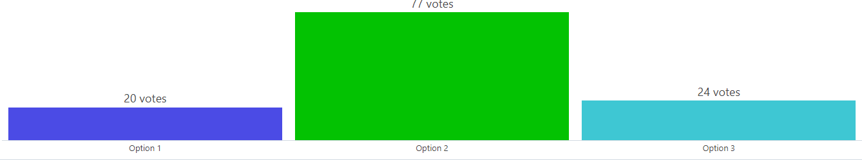
- The School Council agreed that lots of the suggestions were actually going to be good ideas to try and implement in the classrooms but it was obvious that a display was the most favoured option.
- The School Council are going to research some of their own examples from their classrooms and bring to the next meeting so that we can write to Ms Nunn.
- The next class meeting which will be set up next week is going to be based around how we can make the school more environmentally friendly and the School Council are going to use this week to think of some suggestions for options to give for the class meeting.

Actions:
- School Council members to research examples of good emotions displays.
- School Council members to think of options for ways that we can be more environmentally friendly and bring suggestions next time for creating the class meeting.

