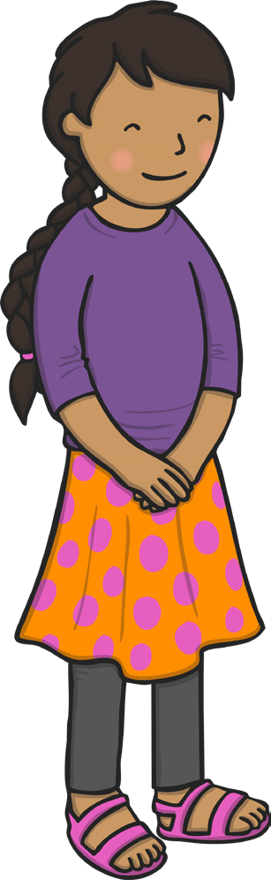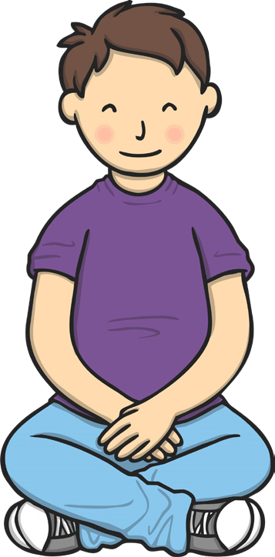
twinkl.com
twinkl.com
1
2
I can calm myself down
I can calm myself down
Take deep breaths.
Keep hands and

feet to myself.
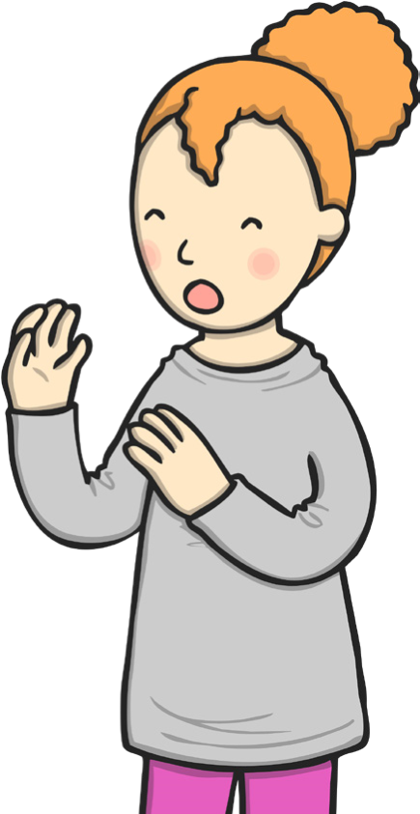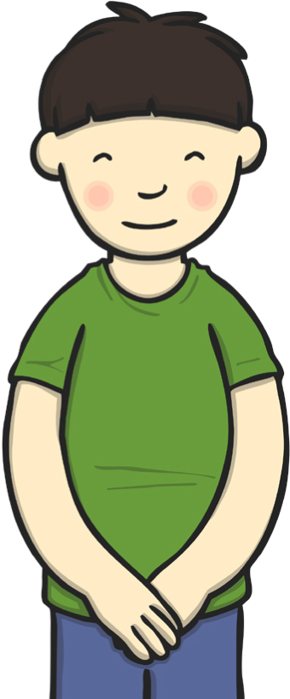
twinkl.com
twinkl.com
3
4
I can calm myself down
I can calm myself down
Count to ten.
Think about what I
am trying to say.
1
, 2, 3, 4, 5,

6
10
, 7, 8, 9,

