I love me!
This is a picture of me

5 things I like about me | 5 things I am grateful for
1.  2.  3.  4.  5. | 1.  2.  3.  4.  5.
Remember….  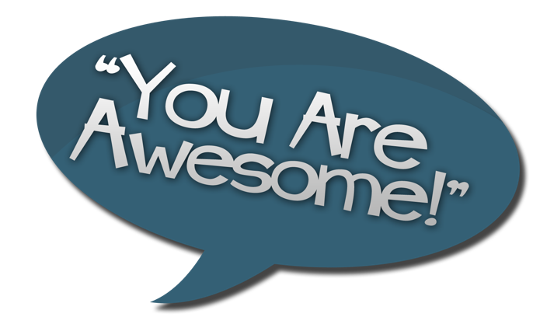 | I am proud of myself because..
3 great things I have done this week | 3 things I would like to achieve next week
1.  2.  3. | 1.  2.  3.


